Hello WILD women!

What a great Winter Event! More than 40 women joined us for a day of solidarity, education, and power-building! We had 160% attendance! Not only did nearly all the registrants attend, but we had 14 walk-ins that day who had heard about the program through various networks.

We had women from all over the state! Women from IATSE, LiUNA local 223, UA Plumbers Local 24, 1199 SEIU, IUPAT DC 35 Local 1044, IBEW Local 103, Local 1445, Pipefitters 537, and Neighbor 2 Neighbor, Brockton Workers Alliance, Mass Alliance, and the Lynn Workers Center and more!

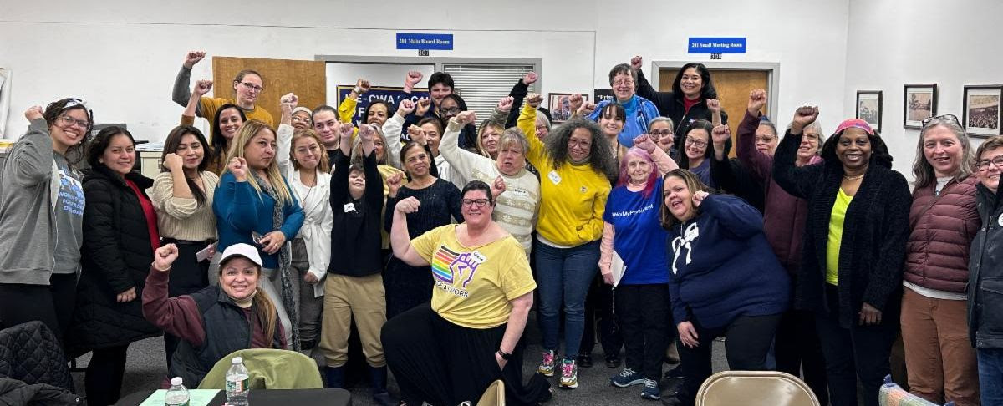

If you weren’t able to attend, here is a brief overview.

The Morning Program started with Lisa Lemieux, President of the Greater Southeastern MA Labor Council acknowledging the ancestral territory of the Naumkeag native people, whose land the North Shore Labor Council’s space sits within.

We were excited to welcome Chrissy Lynch, President of the MASS AFL-CIO, who started us off with an update on state and national politics and how we need to build a movement that can fight back. Solidarity with immigrant struggles is a part of labor unions’ history and only together will we have the power to build a future that benefits everyone.

President Lynch highlighted an Immigration Toolkit built by the national AFL-CIO that people may find helpful to use. It is attached to this email.

The first session of the day was facilitated by Isabel Lopes, Founder & Director of Brockton Workers Alliance (BWA), and Anneta Argyres, Director of the Labor Extension at UMass Boston. They led a workshop on Sexual Harassment in the workplace.

Volunteers and tables practiced identifying harassment activities, and how to address them, including who to report behavior to. They also discussed case studies of how individuals collectively addressed the issues by creating policies that would dissuade the behavior in the future.

The Afternoon Program:
- Beth Kontos, Vice President of the North Shore Labor Council was the MC and led the afternoon team, as well as spoke a bit about immigration.
- Alexandra Piñeiros Shields, an Associate Professor at Brandeis Heller, presented a slideshow of what she has been witnessing first hand regarding the women and children being held at the border. She also defined and explained the ideals of third-, second-, and first-dimensional power.
- The first dimension is about who wins the game - like elected leaders. They “win” over an opponent to then have the power.
- The 2nd dimension is about those who create the rules of the game. This pool is much larger, and we’d like to think that in a democracy, these are the majority of people, but we know that sometimes those who are elected, are also those who pick the rules. For example, the rules about who can and cannot vote/run for office narrow down who is allowed into the first dimension. Those who control the agenda, control the power.
- The 3rd dimension is who controls the knowledge and narratives that justify who wins and loses. Stories and knowledge define what is possible and create alternative outcomes. Media, but also social storytelling inside communities can be nurtured and developed to influence power that is more in line with the justice needed.

After Alexandra’s dive into understanding power, the panelists were invited to share more about what they are doing to support immigrant communities in their dimensions of power.

- Sarah Wilfred, Director of Education Policy at AFT Mass, Tatiana Begault, Executive Director of MASS COSH, and Vilma Zavala, Community Organizer at the Lynn Worker Center, had a panel discussion about immigration and talked about the work they’re doing.

In closing, we heard from attendees about the immediate needs they are seeing - from partnerships with the majority groups to protect immigrant families by checking in on them, the need for networks of qualified and verified information, and the sharing of resources for groups who are doing the work. Women were asked to take a pledge to join the commitment.

Included:
- Immigration Toolkit
- Resource list
- How to identify Sexual Harassment handout
- MassCOSH resources: 1. ICE 2. Know your rights 3. LGBTQ+
- ICE Red cards

Thank you to our partners & sponsors, the Mass AFL-CIO, North Shore Labor Council, Mass Teachers Alliance (MTA), American Federation of Teachers (AFT-MA), Mass Nurses Association (MNA), Merrimack Valley Labor Council, Amalgamated Bank, and to all the people who sent women from their organizations.

All of this wouldn’t be possible without the support from all of you amazing women.
Thank you to our Curriculum Committee, Kim Wilson - Chair, Anneta Argyres, Susan Winning, Clare Hammonds, Tolle Graham, Elizabeth Pellerito, Dale Melcher, and Kafunda Banks.

And thank you to the Program Committee who put it together! Ann O'Connor - Chair, Tess Ewing, Jodie Dow, Emily Kibbe, Vanessa La Rocque,, Maria Bastardo, Bianca Pierre, and Lisa Lemieux.

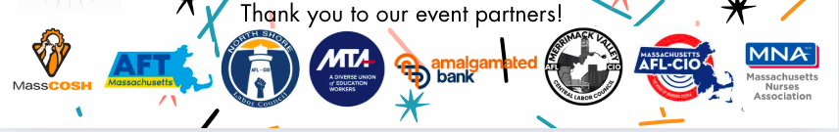

If you enjoyed the WILD in the Winter we invite you to get EVEN MORE WILD this summer at the Summer Institute. Imagine spending 3 days with your sisters learning, networking, and building solidarity.

Let us know if you are interested in attending (especially if you have children!) at
https://secure.lglforms.com/form_engine/s/nReLc2uc3k0EcY6irYw1Rw and we will get you more details as they are developed.

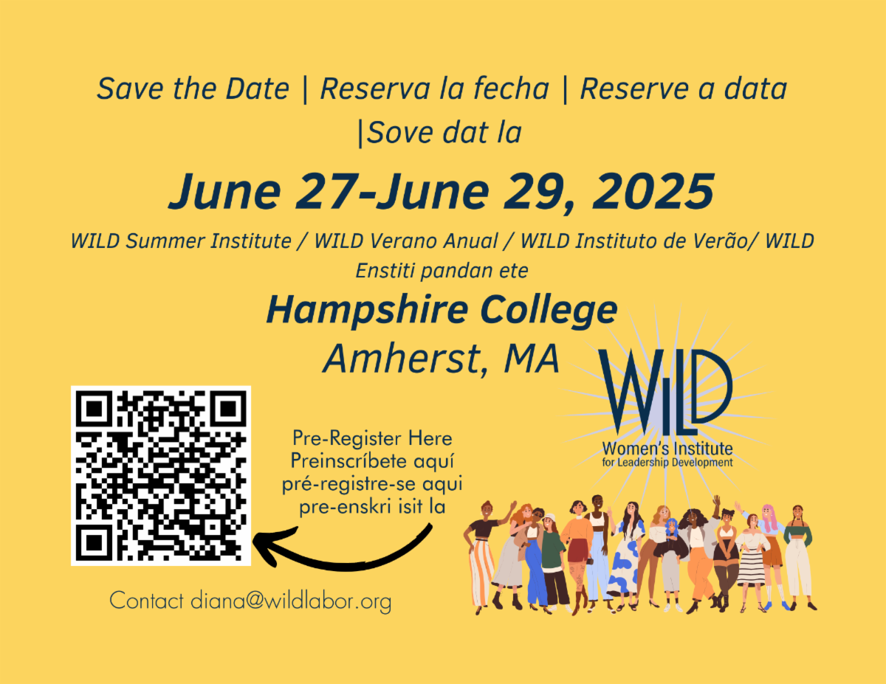

Join the Women's Committee of the North Shore Labor Council for a Movie Night!

The Women's Committee of the North Shore Labor Council is proud to present an inspiring documentary about Dolores Huerta, a fearless activist.

The Dolores Huerta Documentary chronicles Huerta's remarkable journey from her childhood in Stockton, California, to her early years with the United Farm Workers. It highlights her pivotal role in the 1965 grape boycott and her significant contributions to the feminist movement of the 1970s. It showcases her enduring commitment to activism as she fought against gender bias and navigated successes and challenges in labor unions.

The documentary also reveals how Dolores's passion for justice shaped the lives of her 11 children. Through her influential work as a community organizer, she fought against police brutality and championed women's rights, leaving an unforgettable mark on society. Her impact, which continues to inspire and motivate us today, is a testament to the enduring power of activism.

Your presence at this event is appreciated and essential to the success of our cause. We look forward to seeing you there and sharing this inspiring story!

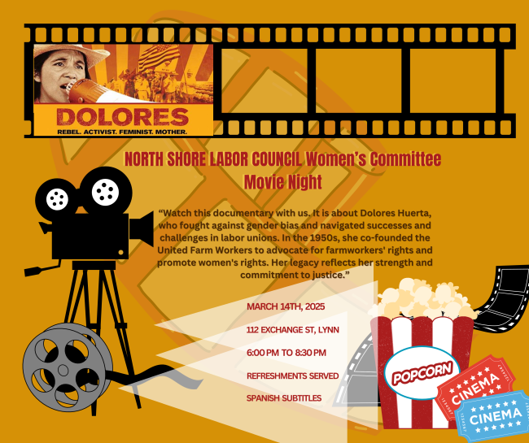

¡Hola Mujeres WILD!

¡Qué gran evento de invierno! ¡Más de 40 mujeres se unieron a nosotras para un día de solidaridad, educación y fortalecimiento! ¡Tuvimos una asistencia del 160%! No solo asistieron casi todas las inscritas, sino que tuvimos 14 asistentes ese día que habían oído hablar del programa a través de varias redes.

¡Tuvimos mujeres de todo el estado! Mujeres de IATSE, LIUNA local 223, UA Plumbers Local 24, 1199 SEIU, IUPAT DC 35 Local 1044, IBEW Local 103, Local 1445, Pipefitters 537, Neighbor 2 Neighbor, Brockton Workers Alliance, Mass Alliance y Lynn Workers Center, ¡y más!

Si no pudiste asistir, aquí tienes una breve descripción general.

El programa de la mañana comenzó con Lisa Lemieux, presidenta del Greater Southeastern MA Labor Council, reconociendo el territorio ancestral del pueblo nativo Naumkeag, en cuya tierra se encuentra el espacio del North Shore Labor Council.

Estábamos emocionados de dar la bienvenida a Chrissy Lynch, presidenta de la AFL-CIO de Massachusetts, quien nos inició con una actualización sobre la política estatal y nacional y cómo debemos construir un movimiento que pueda contraatacar. La solidaridad con las luchas de los inmigrantes es parte de la historia de los sindicatos y solo juntos tendremos el poder de construir un futuro que beneficie a todos.

La presidenta Lynch destacó un kit de herramientas de inmigración creado por la AFL-CIO nacional que las personas pueden encontrar útil. Se adjunta a este correo electrónico.

La primera sesión del día fue facilitada por Isabel Lopes, fundadora y directora de Brockton Workers Alliance (BWA), y Anneta Argyres, directora de la extensión laboral en UMass Boston. Dirigieron un taller sobre acoso sexual en el lugar de trabajo.

Los voluntarios y las mesas practicaron la identificación de actividades de acoso y cómo abordarlas, incluso a quién denunciar el comportamiento. También discutieron estudios de casos de cómo las personas abordaron colectivamente los problemas mediante la creación de políticas que disuadirían el comportamiento en el futuro.

El programa de la tarde:
- Beth Kontos, vicepresidenta del Consejo Laboral de North Shore, fue la presentadora y dirigió el equipo de la tarde, y también habló un poco sobre inmigración.
- Alexandra Piñeiros Shields, profesora asociada en Brandeis Heller, presentó una presentación de diapositivas de lo que ha presenciado de primera mano con respecto a las mujeres y los niños detenidos en la frontera. También definió y explicó los ideales del poder de tercera, segunda y primera dimensión.
- La primera dimensión trata sobre quién gana el juego, como los líderes electos. Ellos "ganan" sobre un oponente para luego tener el poder.
- La segunda dimensión trata sobre aquellos que crean las reglas del juego. Este grupo es mucho más grande y nos gustaría pensar que, en una democracia, esta es la mayoría de las personas, pero sabemos que, a veces, quienes son elegidos también son quienes eligen las reglas. Por ejemplo, las reglas sobre quién puede y quién no puede votar o presentarse a un cargo limitan a quién puede entrar en la primera dimensión. Quienes controlan la agenda controlan el poder.
- La tercera dimensión es quién controla el conocimiento y las narrativas que justifican quién gana y quién pierde. Las historias y el conocimiento definen lo que es posible y crean resultados alternativos. Los medios de comunicación, pero también las narraciones sociales dentro de las comunidades, pueden nutrirse y desarrollarse para influir en el poder que esté más en línea con la justicia necesaria.

Después de que Alexandra se sumergiera en la comprensión del poder, se invitó a los panelistas a compartir más sobre lo que están haciendo para apoyar a las comunidades inmigrantes en sus dimensiones de poder.

- Sarah Wilfred, directora de Política Educativa en AFT Mass, Tatiana Begault, directora ejecutiva de MASS COSH, y Vilma Zavala, organizadora comunitaria en el Lynn Worker Center, tuvieron una mesa redonda sobre inmigración y hablaron sobre el trabajo que están haciendo.

Para cerrar, escuchamos a los asistentes sobre las necesidades inmediatas que están viendo: desde asociaciones con los grupos mayoritarios para proteger a las familias inmigrantes al controlarlas, la necesidad de redes de información calificada y verificada, y el intercambio de recursos para los grupos que están haciendo el trabajo. Se pidió a las mujeres que se comprometieron a sumarse al compromiso.

Incluidos:
- Kit de herramientas para la inmigración
- Lista de recursos
- Folleto “Cómo identificar el acoso sexual”
- MassCOSH recursos: 1. ICE 2. Conozca sus derechos 3. LGBTQ+
- ICE Tarjetas rojas

Gracias a nuestros socios y patrocinadores, la AFL-CIO de Massachusetts, el Consejo Laboral de North Shore, la Alianza de Maestros de Massachusetts (MTA), la Federación Estadounidense de Maestros (AFT-MA), la Asociación de Enfermeras de Massachusetts (MNA), el Consejo Laboral de Merrimack Valley, el Banco Amalgamated y a todas las personas que enviaron mujeres de sus organizaciones.

Todo esto no sería posible sin el apoyo de todas ustedes, mujeres maravillosas.
Gracias a nuestro Comité de Currículo, Kim Wilson (presidenta), Anneta Argyres, Susan Winning, Clare Hammonds, Tolle Graham, Elizabeth Pellerito, Dale Melcher, Kafunda Banks.

¡Y gracias al Comité del Programa que lo organizó! Ann O'Connor (presidenta), Tess Ewing, Jodie Dow, Emily Kibbe, Vanessa La Rocque, Maria Bastardo, Bianca Pierre y Lisa Lemieux.

Si disfrutaste de WILD en invierno, te invitamos a ser AÚN MÁS WILD este verano en el Instituto de Verano. Imagina pasar 3 días con tus hermanas aprendiendo, creando redes y generando solidaridad.

Avísanos si estás interesada en asistir (¡especialmente si tienes hijos!) en
https://secure.lglforms.com/form_engine/s/nReLc2uc3k0EcY6irYw1Rw y te brindaremos más detalles a medida que los vayamos desarrollando.

¡Únase al Comité de Mujeres del Consejo Laboral de North Shore para una noche de película!

El Comité de Mujeres del Consejo Laboral de North Shore se enorgullece de presentar un documental inspirador sobre Dolores Huerta, una activista intrépida.

Este documental de Dolores Huerta narra el extraordinario viaje de Huerta desde su infancia en Stockton, California, hasta sus primeros años con la Unión de Campesinos. Destaca su papel fundamental en el boicot a la uva de 1965 y sus importantes contribuciones al movimiento feminista de la década de 1970. Muestra su compromiso duradero con el activismo mientras luchaba contra los prejuicios de género y navegaba por los éxitos y desafíos en los sindicatos.

El documental también revela cómo Dolores pasión por la justicia influyó en la vida de sus 11 hijos. A través de Dolores influyente trabajo como organizadora comunitaria, luchó contra la brutalidad policial y defendió los derechos de las mujeres, dejando una huella inolvidable en la sociedad. Su impacto, que sigue inspirándonos y motivándonos hoy en día, es un testimonio del poder perdurable del activismo.

Su presencia en este evento es apreciada y es fundamental para el éxito de nuestra causa. ¡Esperamos verte allí y compartir esta inspiradora historia!

Olá Mulheres da WILD!

Que evento de inverno otíma! Mais de 40 mulheres se juntaram a nós para um dia de solidariedade, educação e fortalecimento! Tivemos 160% de atendimento! Não tivemos só todos que registraram presente, mas tivemos 14 pessoas a mais naquele dia que ficaram sabendo do programa através de várias redes.

Tivemos mulheres de todo o estado! Mulheres de IATSE, LiUNA local 223, UA Plumbers Local 24, 1199 SEIU, IUPAT DC 35 Local 1044, IBEW Local 103, Local 1445, Pipefitters 537, e Neighbor 2 Neighbor, Brockton Workers Alliance, Mass Alliance, e o Lynn Workers Center e mais!

Se você não conseguiu comparecer, aqui está uma breve visão geral.

The Morning Program started with Lisa Lemieux, President of the Greater Southeastern MA Labor Council acknowledging the ancestral territory of the Naumkeag native people, whose land the North Shore Labor Council’s space sits within.

O programa matinal começou com Lisa Lemieux, Presidente do Greater Southeastern MA Labor Council, reconhecendo o território ancestral do povo nativo Naumkeag em cuja terra fica o espaço do North Shore Labor Council.

Ficamos animados em receber Chrissy Lynch, Presidente da MASS AFL-CIO, que nos iniciou com uma atualização sobre a política estadual e nacional e como precisamos construir um movimento que possa revidar. A solidariedade com as lutas dos imigrantes faz parte da história dos sindicatos e somente juntos teremos o poder de construir um futuro que beneficiaria a todos.

A Presidente Lynch destacou um folheto de imigração criado pela AFL-CIO nacional que as pessoas podem achar útil usar. Está anexado a este e-mail.

A primeira sessão do dia foi facilitada por Isabel Lopes, Fundadora e Diretora da Brockton Workers Alliance (BWA), e Anneta Argyres, Diretora da Labor Extension na UMass Boston. Elas lideraram um treinamento sobre Assédio Sexual no local de trabalho.

Voluntários e mesas praticaram identificando atividades de assédio e como lidar com elas, incluindo a quem relatar o comportamento. Elas também discutiram estudos de caso de como indivíduos coletivamente os problemas criando políticas que dissuadiram o comportamento no futuro.

Programa da Tarde:
- Beth Kontos, vicepresidenta del Consejo Laboral de North Shore, fue la presentadora y dirigió el equipo de la tarde, y también habló un poco sobre inmigración.
- Alexandra Piñeiros Shields, professora associada da Brandeis Heller, apresentou uma apresentação do que ela tem testemunhado em primeira mão sobre as mulheres e crianças mantidas na fronteira. Ela também definiu e explicou as ideias de poder de terceira, segunda e primeira dimensões.
- A primeira dimensão é sobre quem ganha o jogo - como líderes eleitos. Eles “ganham” sobre um oponente para daí ter o poder.
- A 2ª dimensão é sobre aqueles que criam as regras do jogo. Esse grupo é bem maior e gostaríamos de pensar que, em uma democracia, essas são a maioria das pessoas, mas sabemos que, às vezes, aqueles que são eleitos também são aqueles que escolhem as regras. Por exemplo, as regras sobre quem pode e não pode votar/concorrer a um cargo restringem quem tem permissão para entrar na primeira dimensão. Aqueles que controlam a agenda, controlam o poder.
- A 3ª dimensão é quem controla o conhecimento e as narrativas que justificam quem ganha e quem perde. Histórias e conhecimento definem o que é possível e criam resultados alternativos. A mídia, mas também a narrativa social dentro das comunidades, podem ser nutridas e desenvolvidas para influenciar o poder que está mais alinhado com a justiça necessária.

Após o mergulho de Alexandra na compreensão do poder, os painelistas foram convidados a compartilhar mais sobre o que estão fazendo para apoiar as comunidades de imigrantes em suas dimensões de poder.

- Sarah Wilfred, Diretora de Política Educacional da AFT Mass, Tatiana Begault, Diretora Executiva da MASS COSH, e Vilma Zavala, Organizadora Comunitária do Lynn Worker Center, tiveram um painel de discussão sobre imigração e falaram sobre o trabalho que estão fazendo.

Para encerrar, ouvimos dos participantes sobre as necessidades imediatas que eles estão vendo - desde parcerias com os grupos majoritários para proteger as famílias imigrantes verificando-as, a necessidade de redes de informações qualificadas e verificadas, e o compartilhamento de recursos para grupos que estão fazendo o trabalho. As mulheres foram convidadas a fazer um juramento para se juntar ao compromisso.

Incluidos:
- Folheto/Kit de imigração
- Lista de recursos
- Folheto sobre como identificar assédio sexual
- MassCOSH resources: 1. ICE 2. Conheça seus direitos 3. LGBTQ+
- ICE Cartões vermelhos

Agradecemos os parceiras e patrocinadoras, Mass AFL-CIO, North Shore Labor Council, Mass Teachers Alliance (MTA), American Federation of Teachers (AFT-MA), Mass Nurses Association (MNA), Merrimack Valley Labor Council, Amalgamated Bank e todas as pessoas que enviaram mulheres de suas organizações.

Tudo isso não seria possível sem o apoio de todas vocês, mulheres incríveis.
Obrigado ao nosso Comitê de Currículo, Kim Wilson - Presidente, Anneta Argyres, Susan Winning, Clare Hammonds, Tolle Graham, Elizabeth Pellerito, Dale Melcher e Kafunda Banks.

E obrigada ao Comitê do Programa que organizou tudo isso! Ann O'Connor - Chair, Tess Ewing, Jodie Dow, Emily Kibbe, Vanessa La Rocque, Maria Bastardo, Bianca Pierre, and Lisa Lemieux.

Se você gostou do WILD no Inverno, convidamos você a ficar AINDA MAIS WILD neste verão no Instituto de Verão. Imagine passar 3 dias com suas irmãs aprendendo, fazendo redes e construindo solidariedade.

Informe-nos se você estiver interessado em participar (especialmente se você tem filhos!) aqui: https://secure.lglforms.com/form_engine/s/nReLc2uc3k0EcY6irYw1Rw e lhe daremos mais detalhes quando soubermos mais.

Junte-se ao Comitê de Mulheres do Conselho Trabalhista de North Shore para uma Noite de Cinema!

*Este filme está sendo apresentado em inglês com legendas em espanhol!*

WILD | 108 Myrtle St. 4th Floor | Quincy, MA 02171 US

Unsubscribe | Update Profile | Constant Contact Data Notice



